GTB  
  
**QA**  
[DEV 20.24] OT-815 | XT | ES | AS | Fiesta PI-scored 3.0 Popin – 18 June 2020

**Jira ticket:**  
<https://jira.uhub.biz/browse/GTBEMEAOPT-815>

**Site**  
<https://www.ford.es/>

**Test location**  
Homepage Rotation

**Hypothesis**  
Analysis on the TDR Popin and UC5 has shown that there are improvements that can be made in terms of the audience we target. Currently, the BP-A and BP-C popin targets a broad audience, which might have converted regardless of the popin. We believe that using PI scores to filter out audiences can make the popin much cleverer and more proactive in anticipating user behaviour and push users to conversion earlier than they would have.

**Test Description**

Below are the actions that can be done. Reference will be made to the bold segment of each of these actions to see how you would trigger these. All of these actions assume that you’ve already opened the relevant QA Link and that you’re on the home page. The QA Links all go to the home page when opened.

This test is only focused on the Fiesta.

**NPP**: To do this, mouse over the “Vehículos” link. It can be found the top left of the page on the main navigation header. Next click on the “FIESTA”. The action is now complete and you’re on the NPP.

**BRD:** There are 2 ways to do this. The first method requires you to click on the “Acceso rápido” link. It can be found at the top right corner of the page in the mini header. Once clicked a dropdown menu will appear, click on “Descarga de catálogo” next. You are now on the Brochure page. Next click on the Fiesta, Either the vehicle or the blue text underneath the vehicle. The word itself cannot be clicked. A popup will appear allowing you to click on buttons to download the Brochures. The action is now complete.  
  
The second method requires that you do the **NPP** action first. Once completed, scroll down on the page until you reach a blue block containing a few actions, one of these actions has a little book as an icon and below the icon it has “Descarga el catálogo” written. Click on this. A popup will appear allowing you to click on buttons to download the Brochures. The action is now complete.

**KMI:** To do this, scroll down to the bottom of the page. In the bottom right corner, just above the Ford logo is a link with a newsletter icon next to it, that says “Mantenme informado”. Click this link. Once the page is loaded, click on any of the “Fiesta” vehicles, at the time of writing this brief, there are 3. “Fiesta”, “Fiesta GLP” and “Fiesta ST”. Once you’ve clicked on one of them, it’ll get a little checkmark to indicate that it’s been selected. This action is now complete.

**BP**: To do this click on the link that says “Configurador”. It can be found in the top right of the page on the main navigation header. Next click on the “FIESTA”. This action is now complete.

**C2C:** To do this, you firstly need to do the **NPP** action. Once complete 3 links can complete this action. The first method is clicking on the link that says “Te llamamos”. It can be found just below the main header on the right. Once clicked the action is complete. The second method is looking to the left of the screen. There’s a blue bar in the middle on the edge of the screen that follows you as your scroll down. If you click on the telephone icon the action will also be complete. The third and final method requires you to scroll to the bottom of the page until you reach a blue block containing a few actions ( this is the same block referenced in the second method of **BRD** ). One of these actions has a little telephone as an icon and below the icon it has “Te llamamos” written. Click on this. The action is now complete.

**TDR:** There are 3 ways to do this. The first method requires you to click on the link “Prueba”. It is found in the main header at the top right of the screen. Once on the new page, click on any of the Fiesta vehicles. At the time of writing, there are 2, which include the “Fiesta” and the “Fiesta ST”. The action is now complete. The second method requires that you do the **NPP** action. Once complete you can click on the link that says “Pruébalo”, this will open a popup. The action is now complete. The third method is scrolling to the bottom of the screen until you reach a blue block containing a few actions. One of these actions has a little steering wheel as an icon and below the icon it has “Pruébalo” written. Click on this, this will open a popup. The action is now complete. The third and final method is looking to the far left of your screen. There’s a blue bar in the middle on the edge of the screen that follows you as your scroll down. If you click on the steering wheel icon the action will now be complete.

**Testing the Activity:**

Upon viewing any of the RANGE X ( where X is 1, 2, 3 or 4) QA Links, you will be placed on the homepage. If you have done any of these actions in the same session you will get a popup immediately. In other words if you open RANGE 4, do one of the action then open RANGE 3 you will get a popup. A Popup can only display up to 3 times with a 15-minute duration between these popups.

All the popups look the same, the only difference is the button.

Desktop Popup: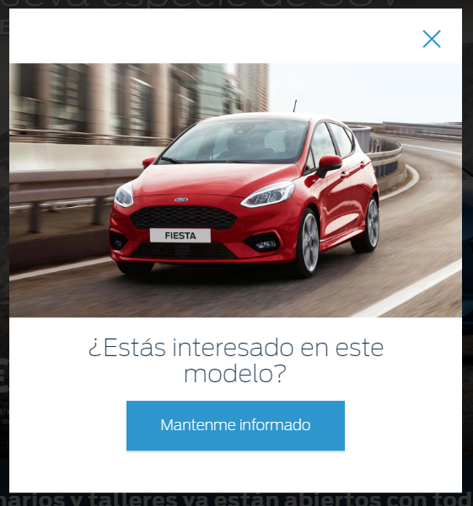

Mobile Popup:  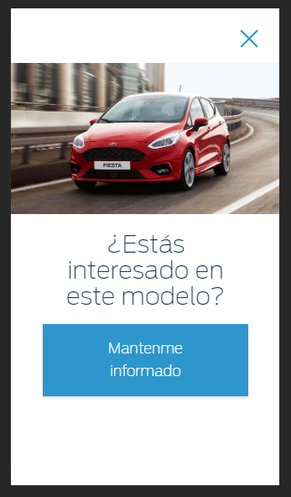

View the **Range 4 QA Link**. The buttons available on this popup are the **C2C**, the **TDR** and Inventory. With that as the priority. If you have done any action that’s not **C2C** you will see the **C2C** button on the popup. If you have done the **C2C** action, you will see the **TDR** button and if you have done both the **C2C** and **TDR** action you will see an inventory button. Lastly, if the popup appears with the **C2C** button and you click on the button, you will also have completed the **C2C** action, this is true for all of the buttons. If it’s **TDR** and you click it, you would have completed the **TDR** action.

The **C2C** button will say “Te llamamos” and when clicked will go to this link > <https://www.infoford.es/c2c/iframe/nameplate_gux/?turismos-nuevo-fiesta>

The **TDR** button will say “Pruébalo” and when clicked will go to this link > <https://www.ford.es/compra/encuentra/prueba-de-vehiculo?vehicleCode=00M>

The Inventory button will say “Encuéntralo en stock” and when clicked will go to this link > <https://www.fordwebstore.es/disponibilidad-vehiculos-en-stock/resultados/filtro/modelo/051/min-price/12.035/max-price/16.631/order/1>

View the **Range 3 QA Link**. The buttons available on this popup are the **BP**, the **C2C** and the FDR. With that as the priority. If you have done any action that’s not **BP** you will see the **BP** button on the popup. If you have done the **BP** action, you will see the **C2C** button and if you have done both the **BP** and **C2C** action you will see an FDR button. Lastly, if the popup appears with the **BP** button and you click on the button, you will also have completed the **BP** action, this is true for all of the buttons. If it’s **C2C** and you click it, you would have completed the **C2C** action.

The **BP** button will say “Configura tu Fiesta” and when clicked will go to this link > <https://www.ford.es/compra/encuentra/configurador-gf3#/catalogID/WAEEX-CE1-2015-B479FiestaCarESP202025/>

The **C2C** button will say “Te llamamos” and when clicked will go to this link > <https://www.infoford.es/c2c/iframe/nameplate_gux/?turismos-nuevo-fiesta>

The FDR button will say “Busca tu concesionario” and when clicked will go to this link > <https://www.ford.es/busca-concesionario>

View the **Range 2 QA Link**. The buttons available on this popup are the **BP** and the **BRD**. With that as the priority. If you have done any action that’s not **BP** you will see the **BP** button on the popup. If you have done the **BP** action, you will the **BRD** button. Lastly, if the popup appears with the **BP** button and you click on the button, you will also have completed the **BP** action, this is true for all of the buttons. If it’s **BRD** and you click it, you would have completed the **BRD** action. If both **BP** and **BRD** actions have been done, it’ll pretend it’s a Range 3 QA Link and show the **C2C** button, if **C2C** has been done it’ll do the FDR button.

The **BP** button will say “Configura tu Fiesta” and when clicked will go to this link > <https://www.ford.es/compra/encuentra/configurador-gf3#/catalogID/WAEEX-CE1-2015-B479FiestaCarESP202025/>

The **BRD** button will say “Descarga tu catálogo” and when clicked will go to this link > <https://www.ford.es/compra/encuentra/descarga-de-catalogo#overlay/content/overlays/download-a-brochure/new-fiesta>

The **C2C** button will say “Te llamamos” and when clicked will go to this link > <https://www.infoford.es/c2c/iframe/nameplate_gux/?turismos-nuevo-fiesta>

The FDR button will say “Busca tu concesionario” and when clicked will go to this link > <https://www.ford.es/busca-concesionario>

View the **Range 1 QA Link**. The buttons available on this popup are the **KMI** and the **BRD**. With that as the priority. If you have done any action that’s not **KMI** you will see the **KMI** button on the popup. If you have done the **KMI** action, you will the **BRD** button. Lastly, if the popup appears with the **KMI** button and you click on the button, you will also have completed the **KMI** action, this is true for all of the buttons. If it’s **BRD** and you click it, you would have completed the **BRD** action. If both **KMI** and **BRD** have been done, it’ll pretend it’s a Range 2 QA Link and show the **BP** button. If **BP** has also be done it’ll show the **C2C** button and if that has also been done you’ll see the FDR button.

The **KMI** button will say “Mantenme informado” and when clicked will go to this link > <https://www.ford.es/compra/encuentra/mantenme-informado?vehicleCode=00M>

The **BRD** button will say “Descarga tu catálogo” and when clicked will go to this link > <https://www.ford.es/compra/encuentra/descarga-de-catalogo#overlay/content/overlays/download-a-brochure/new-fiesta>

The **BP** button will say “Configura tu Fiesta” and when clicked will go to this link > <https://www.ford.es/compra/encuentra/configurador-gf3#/catalogID/WAEEX-CE1-2015-B479FiestaCarESP202025/>

The **BRD** button will say “Descarga tu catálogo” and when clicked will go to this link > <https://www.ford.es/compra/encuentra/descarga-de-catalogo#overlay/content/overlays/download-a-brochure/new-fiesta>

The **C2C** button will say “Te llamamos” and when clicked will go to this link > <https://www.infoford.es/c2c/iframe/nameplate_gux/?turismos-nuevo-fiesta>

The FDR button will say “Busca tu concesionario” and when clicked will go to this link > <https://www.ford.es/busca-concesionario>

The sections where the QA Link pretends to be a QA Link is highly unlikely to happen once it goes live, however from our testing perspective it could happen as we’re using links to force the user to fall in a certain range.

Lastly the **All Visitors QA Link** has no popup. It’s only purpose is to gather information when one of the actions have been done. In other words, if you wanted to test that it works, you could do any one of the actions after viewing the **All Visitors QA Link** and then proceed to opening one of the **RANGE X QA Links**. A Popup should then display, following the rules set out above.

**Browser:**   
All  
  
**Device:**   
All  
  
**Audience rules:**   
All traffic

**QA Links:**

**RANGE 4 - 0.1:**

<https://www.ford.es/?at_preview_token=PNHN3LuLNawb0or-9Y9yOw&at_preview_index=1_1&at_preview_listed_activities_only=true>

**RANGE 3 - 0.011 and 0.1:**

<https://www.ford.es/?at_preview_token=PNHN3LuLNawb0or-9Y9yOw&at_preview_index=1_2&at_preview_listed_activities_only=true>

**RANGE 02 - 0.0031 and 0.01:**

<https://www.ford.es/?at_preview_token=PNHN3LuLNawb0or-9Y9yOw&at_preview_index=1_3&at_preview_listed_activities_only=true>

**RANGE 01 - 0.0000001 and 0.003:**

<https://www.ford.es/?at_preview_token=PNHN3LuLNawb0or-9Y9yOw&at_preview_index=1_4&at_preview_listed_activities_only=true>

**All Visitors:**

<https://www.ford.es/?at_preview_token=PNHN3LuLNawb0or-9Y9yOw&at_preview_index=1_5&at_preview_listed_activities_only=true>